**Quota and Spike Arrest Analysis**

API Tested: sampletest2

**Use Case**: To test the sampletest2 API with multiple consumers App to achieve the spikerate is based on API-specific to protect the target and Quota is Customer-specific based on the count mentioned in API Product.

**Traffic Management Configuration:**

* **Quota**
* Two customers requesting sampletest2 API: One is a Gold Customer with a quota plan of 15 requests per minute and another is a Silver Customer with a quota plan of 10 requests per minute.
* 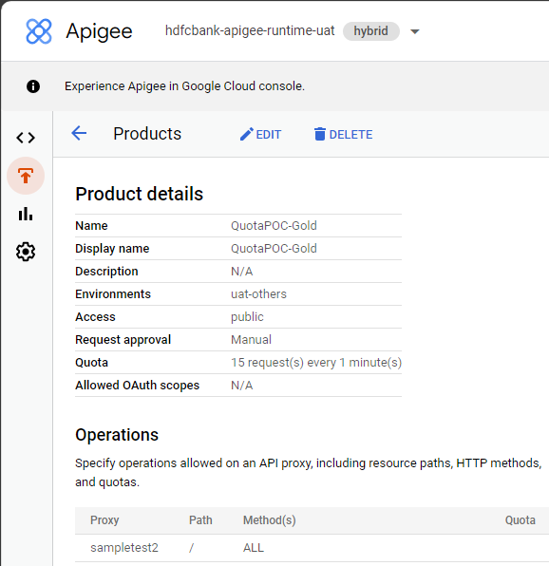A screenshot of a computer

  Description automatically generated
* **SpikeRate**
* Rate is 20 pm for sampletest2 API.
* A screenshot of a computer program

  Description automatically generated
* The spike arrest rate policy allows a maximum of 20 requests per minute. Via smoothing, it is enforced as a maximum of ***one request per 3 seconds (60/20)****.* Whenever there is a spike based on the rate mentioned the request fails.

**Test Ran**

* **Total 13 Request was initiated,** From Gold Customer App 7 request was initiated and from Silver Customer App 6 request.
* **From Gold Customer App,** Total7 Requests were Initiated.
  + Spike Arrest policy counts all 13 requests from that 2 was failed for Gold Customer based on its calculation.
  + Quota Available count was 15 and used was 5.
  + Below docx have test results



* **From Silver Customer App,** Total6 Requests were Initiated.
  + Spike Arrest policy counts all 13 requests from that 1 was failed for Silver Customer based on its calculation.
  + Quota Available count was 10 and used was 4.
  + Below docx have test results



**Note: -** Based on our analysis, we have identified that the spike rate is configured as 5 requests per minute, and the spike arrest policy will allow additional requests within the range of 1% to 3% same we observed in this test as well.